Southwest Iowa Breastfeeding Coalition Meeting
Date: Monday, September 15, 2025
Time: 12:00pm- 1:30pm

Our meeting today will be at Firefly (830 N. 14th Street, Ste. 201) or virtual using the Zoom Link Below
Zoom Virtual option:
https://us02web.zoom.us/j/83156372778?pwd=gY3DfdCUKP7W5VtpLLa7JTV0xFPxjs.1&from=addon

12:00 pm Introductions and agency updates
- Kris Wood, Pottawattamie County WIC- WIC is starting a new moms group—not just breastfeeding! Beginning in October—will be twice per month—from 12-1 pm; if no one shows up by 12:15, they will consider it cancelled
- Jenny Sharrick, Firefly-Maternal Health nurse position is open
- Raelee Thompson, Firefly
- Brittney Christiansen, Methodist Jennie Edmundson- breastfeeding support groups every Wednesday
- Maddy Peppers, Cass Health- OB Nurse Navigator; does one on one breastfeeding support sessions; does Monday Mama Meetups
- Jo Lightner, VNA
- Brooke Sukup, Children’s Nebraska
- Summer Sandholm, Montgomery County Public Health
- Kay Eng, Pottawattamie County WIC
- Brittany Garey, CLC in Southwest Iowa- no longer with Southwest Iowa families, but still supporting breastfeeding parents in Southwest Iowa; working with Chiropractor in Bedford too
- Britni Olson, Cass Health- OB Nurse and CLC
- Cara Cacy, Myrtue Medical Center- recently took a low milk supply course and can provide support to folks experiencing low milk supply
- Janelle Anderson, CHI Mercy- did talk to board member of LC Clinic to let them know that we are aware they no longer have breastfeeding support at the clinic and they could refer to other folks in the community
- Stacia Kennedy, Nebraska Medicine
12:05 pm Old Business
- 2025 goal updates
  - Add one milk depot and/or drop-off site to the existing Iowa Milk Bank Network in our coverage area. Maybe we could draft a letter from the Coalition to support that request. Madelyn is working on one in Missouri Valley at CHI. No updates in March. Would like to get more information from Jean Drulis about the refrigerator temperature tracking so we can better understand where would be a feasible partner.
  - Annually update & communicate out breastfeeding support resources in the service area. This new brochure is available, let us know if you would like some.
  - Provide lactation education for child care providers & recognize them as family friendly businesses. Gathering criteria, sample policy and window cling ideas.
  - Identify World Breastfeeding Week activities. Great activities including, CB Wellness Bash, Glenwood Cultivate Community, Red Oak National Night Out, Lakin Campus Family Friendly Business Recognition and Leach Camper Sales Recognition.
- Posting Bios
  - Send your picture and bio to https://forms.office.com/r/UvQbGDi24i
- Family (Breastfeeding) Friendly Business Recognition.
  - Firefly, VNA, Goodwill, Florence M. Lakin Child Development Center and Leach Camper Sales were recognized in August.
  - Working to do child care businesses next. This will include adoption of a breastfeeding policy (templates provided) and then more structured guidelines of what makes a child care breastfeeding friendly, we will also put additional guidelines on the website on how to do this. This will include taking the Breast Milk Promotion training from the Child Care Nurse Consultant.
    - Can non-registered ECE providers take the breastfeeding training via CCR&R? Jenny will find out this and report back.
    - See attached for template policies and how to document. Give feedback to Kris Wood on the templates and the design of the window cling (ABC blocks) by November meeting so we can incorporate into 2026 goals.
  - Please submit nominations here: https://forms.office.com/r/F8jnMMBNwJ
  - Suggestions?

- Social Media Updates (Instagram Facebook Website)
- Posting Bios
  - Raelee will be out on maternity leave in 5 weeks or so. Hooray for her! Currently posting educational things. Jenny will touch base with her to make sure she has access to the bios.
  - Share things out to get more interaction too!
  - We need to change the Facebook cover photo, but Raelee doesn’t have access to it. Jenny will work with Madeline to make sure that gets done.
- Childcare Lactation Education
- Kit items have been received and working on fillable form for policies. We received kits for 158 registered daycares (bins for fridge and freezer, thermometers for fridge and freezer, laminated CDC breast milk storage and handling poster, breastmilk storage and handling magnets that allow for CCNC cards to be inserted also). Will also share the template policy. CCNCs will take those out to providers as they go out on visits for other reasons.
- Continuing ed & certifications
  - Olson Center continuing education in August was great. Focused on mental health and breastfeeding with mental health medications.

12:50 pm New Business
- Iowa Breastfeeding Coalition update—go to their website if you aren’t familiar. Registration to the Coalition is included in Iowa Breastfeeding Conference. https://iabreastfeeding.org/
- Iowa Breastfeeding Resource Database
  - This has been moved in house at Iowa HHS. https://hhs.iowa.gov/health-prevention/birth-maternal-care/breastfeeding-support/iowa-breastfeeding-resource-database?instance_overrides_key=M5ykrh8KYdLLb9knPR2yJxYy5Q3a9xCmD1R_BF4bZTQ&page=0 Check to see if your agency is included. This posting does require that you have a business address to include, so if you are doing private practice, it will not be posted without an address (this may change at a later date!).
- Coffective update
  - The final reports are done for this and the Coalition’s work with child care providers this year. Unclear if funding will be available from Coffective moving forward, so we should not plan on it.
- Other new business?
  - Baby Showers: Catholic Charities in Council Bluffs in October 17 4-6 pm. Registration opens today (9/15/25). The goal is to serve 100 individuals. Educations presentations on breastfeeding (WIC), maternal mental health (Firefly), ____.
      - Don’t forget as health fair and baby shower season are coming up, that we can use the breastfeeding nook! Contact Kris Wood if you are needing to borrow it.
        - The kit includes tape, first aid kit, milk labels, cords, chairs, and the feather flag to identify that it’s a breastfeeding space.
- Next meeting: November 3 12- 1:30 pm—2026 planning—completely virtual

1:15 pm Adjourn

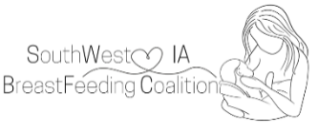
Serving 10 Counties in Iowa including Cass, Crawford, Fremont, Harrison, Mills, Monona, Montgomery, Page, Pottawattamie, Shelby

Family Friendly Business Recognition presentation August 6, 2025 – Lakin Campus Recognition
Firefly, Florence M. Lakin Child Development Center, VNA, Goodwill Industries

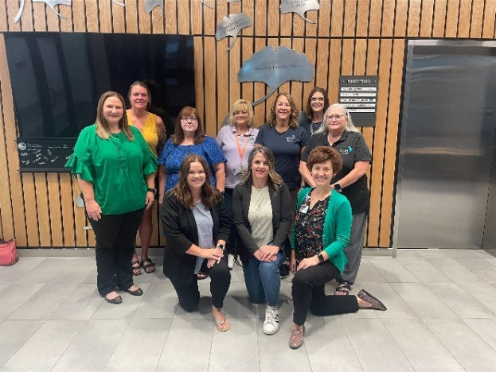
Group photo of all agencies
Front: Maren Larsen, Jessica McGee, Jenny Sharrick
Back: Janelle Peterson, Clarrissa Newman, Kris Wood, Jenny Stom, Kaiya Mears, Barbie Bluml, Jo Lightner

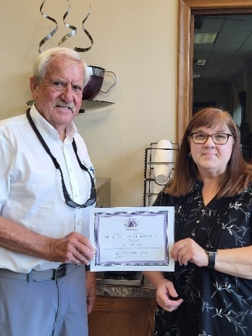
Edd Leach and Kris Wood

